ALYAA BINTI RAMLI
NO 21, PERSIARAN MAHAGONI,
TAMAN MAHAGONI,
05350, ALOR STAR.
KEDAH.

24 NOVEMBER 2015

Dear Sir/Madam

Application for Any Related Position
I am seeking for a full time position where I can use my knowledge in the healthcare industry or management sector. I’ve been trained and learned multiple skills in Healthcare diploma program at Masterskill College. My CGPA is 3.76 and graduated in January 2012.
Your company’s unique involvement and leading position in the healthcare sector has prompted me to apply for a position in your organization that is related to my field. I am very interested in pursuing a career in the field of healthcare. With my knowledge, skills, interest and determination, I strongly believe that I will be able to contribute a great deal to your company.
I look forward to meeting with you at any time and date convenient to you to further discussion. I can be contacted at 013-5273143 or the following email address:
alyaaramli264@yahoo.com
Thank you for your consideration.

Yours sincerely

--------------------------------------------------------
(ALYAA BINTI RAMLI)
Encl: passport sized photograph
: resume

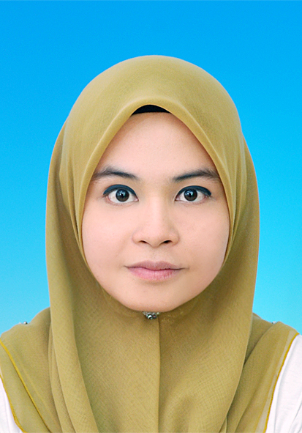
ALYAA BINTI RAMLI
Mailing Address
Address : No 21, Persiaran Mahagoni,
Taman Mahagoni,
05350 Alor Setar,
Kedah.
Contact No : 013-5273143
Email : alyaaramli264@yahoo.com
Personal Particular
Age : 27 years old Date of Birth : 17 March 1988
Nationality : Malaysian Gender : Female
Marital status : Married Ic No. : 880317-35-5028
Health : Excellent Height/Weight : 153cm/47kg
Educational Background
Tertiary Education
Level : Diploma (2009- 2011) CGPA: 3.72 (until semester 9)
Field of study:Healthcare Management
Level : Sijil Tinggi Pelajaran Malaysia Result: C+ (2), C (1), D+ (1)
Level : Malaysian University English Test Result: Band 3
Secondary Education
Level : Sijil Pelajaran Malaysia (2005) Result: 3B(1), 4B(2), 5C(1)
Level : Penilaian Rendah Malaysia (2003) Result: A (2), B (4), C (3)
Primary Educational
Level : Ujian Penilaian Sekolah Rendah (2000) Result: 2A, 2B, 1C
Skills

Computer skills : Microsoft Office Application (Word, Excel, Powerpoint)
Keyboarding skills : 65 words per minute
Other skill : Sales, marketing and business management. Able to conduct and handling industrial’s chemical. Well trained to clinical assist.
Languages
Bahasa Malaysia : Excellent in writing and speaking
English : Moderate in writing and speaking
Arabic : Basic in writing and speaking
Working Experience

- Full time at Giant Hypermarket,
Alor Star, Kedah (2008)
- Almost 8 months
- Worked as a cashier and involving in Customer Services Department.

- Part time at Finisar,
Klebang, Perak (2010)
- Work as a part time guard
- Task: Do body check and monitoring female staff if they went out from department.

- Part time at Pasarayaku,
Taman Perpaduan, Tambun. (2011)
- Work as shop assistant as well as manage stock for department and maintaining good relationship with customer.

- Intern at Perak Medical Center,
Batu Gajah, Perak (2011)
- Handled administration work and assist doctor and patients to do clinical task. Carried out basic office procedures and clerical work as well as providing good services to them.

- Intern at AXA Affin Sdn Bhd,
Silibin, Perak. (2011)
- Meeting public respondent to fill up Questionnaires Form for research purpose. Create pamphlet and blogspot for company usage.
- Trained about marketing skills, make phone calls, office works, and how to approach people.

- Full time at Hovid Bhd,
Chemor Plant. (2012 until now)
- Start working from January 2012 until now
- Work as lab assistant in Quality Control department. Test raw materials received from suppliers and do either chemical or physical test such as NIRS, FTIR, UV or assay to maintain the result acquired to specification given.
- Able to handled chemical and been trained while working.

Activities

Masterskill College of Nursing & Health
2011 : Participate in PIDM Talk in Masterskill College
: Dean’s List Achievement
2010 : Participate in Himpunan Mahasiswa/Mahasiswi Perak in Taiping, Perak
: Participate twice in exploring Gua Tempurung
: Organizing Hari Keluarga Klebang, Bandar Baru Sri Klebang.
: Dean’s List Achievement
2009 : Participate in futsal games at Masterskill College
: Participate in Ipoh International Run

Secondary school
2007 : Participate in Program Jatidiri Kesukarelaan Nasional in Pendang, Kedah
: Involving in Program Keluarga Angkat in Felda Lubuk Merbau

2005 : Represent Pandu Puteri for Kawad Kaki in SMT Seberang Perai, Pulau Pinang
: Participate in Summer Camp by UiTM Kampus Pulau Pinang

Date available: One month notice
Expected Salary: RM 1,500.00 (negotiable)

References
- Name : Mohd Ikramuddin b. Mat Rani
Position : Assistant coordinator / Lecturer
Masterskill College of Nursing and Health
Contact No. : 012-5997917
E-mail : ikramuddin_08@yahoo.com

- Name : En. Johari Amran,
Position : QC Executive, Hovid Berhad
Contact No. : 012-5934330
E-mail : johari@hovid.com

